## **Issues and Resolutions**

| Condition | Resolution |
| --- | --- |
| The ZoneFlex Configurator cannot connect to the ZFM and/or gives “GetADI() Exception” time out error. | 1.  Verify that the ZFM is powered.  2.  Verify that the USB cable is correctly connected.  3.  Verify that the secondary network is configured correctly and ensure you can ping the ZFM as shown in Section 2.2.1.  4.  Ensure you are using the same USB port you used when first setting up the driver. Each USB port is independent.  5.  Check the driver installation again and ensure the RNDIS Gadget appears in Device Manager as shown in Section 2.1.  6.  Ensure there is nothing checked in Internet Options | Connections tab | LAN Settings. |
| Driver cannot find the ZFM at the configured IP address. | Complete the device driver configuration described in Chapter 2.  If this has already been completed, make sure the ZFM is connected to the same USB port that was used when the configuration was performed.  If it is connected to a different USB port, the configuration described in Chapter 2 will need to be completed again for the new port. |
| The ZoneFlex Configurator software cannot be installed on a PC. | Confirm that you have the appropriate rights on the PC. |
| The ZoneFlex Configurator software will not run on a PC. | Confirm that you have the appropriate rights on the PC and that it is available to your user account. |
| I cannot select a tab or the “Back” button. | Check to see if a Yellow Error message is displayed.  If one is displayed, resolve the issue before attempting to navigate to a different screen or tab. |
| I get the following message when I try to open a configuration file:  *File (<filename>.xml) is corrupt and cannot be used.* | The file may have been saved using a different version of the ZoneFlex Configurator.  To resolve this issue, complete one of the following tasks:   * Re-read the configuration from the ZFM, save it to a new file, and delete the corrupt file. * Use the same version of the ZFC that was used to save the original configuration file. * Open the file with a browser, for reference, and re-enter the configuration using the ZFC. |
| Conveyor does not work. There is no heartbeat on the ZFM and the modules only have one green LED ON. | Cycle power to the ZFM. Give the ZFM about 2 minutes to power up completely. If the heartbeat returns, continue to use. If the heartbeat is still missing, turn the ZFM off and replace the SD card with one from another ZFM. If heartbeat returns, hardware is fine, SD card needs to be replaced by ordering one from Intelligrated (very specific). If heartbeat does not return, replace the ZFM. |

## **ZFM and Module LEDs**

Health and status is given through LED indication on both the ZFM and ZFA Modules.  After bootup, a properly running ZoneFlex Manager emits a heartbeat signal with it’s red Status LED, indicating the program is running.

**[TECHCOMM: Can you please copy here 1) the ZFM Layout from Section 3.7.4 of the** [**IQ ZFA Manual**](https://ishare.intelligrated.com/sites/productdocs/Shared%20Documents/Hardware/IntelliQ/Company%20Confidential%20-%20For%20Internal%20Distribution%20Only/IntelliQ%20ZoneFlex%20Advanced%20Product%20Manual.pdf)**]**

The ZFA modules, likewise, indicate a wealth of information through the following LEDs.

**[TECHCOMM: Can you please copy here 2) the Module Pic with LEDs and Tables showing what the LED’s mean from Product Manual (Section 11 in** [**IQ ZFA**](https://ishare.intelligrated.com/sites/productdocs/Shared%20Documents/Hardware/IntelliQ/Company%20Confidential%20-%20For%20Internal%20Distribution%20Only/IntelliQ%20ZoneFlex%20Advanced%20Product%20Manual.pdf)**)]**

## **Locating Bad ZFA Module(s) Process**

Have the following equipment on hand: a network extension cable (male-to-female), and gender changer cables of both types (male-to-male and female-to-female).

With laptop connected to the ZoneFlex Manager, use the ZoneFlex Configurator’s *ZFM Information* screen and note the # of *Detected Modules*.

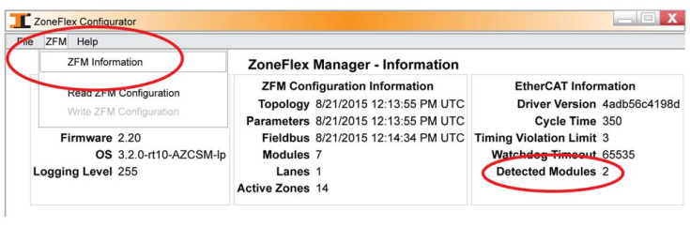

1. Starting at the ZFM, follow the physical connection path of the ZFA network.

2. Count the ZFA Modules and stop at the Module matching the *Detected Count*.

3. Disconnect the module’s cables from both ports.

4. Using the extension/gender changer, connect the outgoing port to the cable supplying

the incoming port.

5. Allow up to 15 seconds for the ZFM to detect the Module.  
6. If the network light comes on, then that Module is good and the next Module is bad.

7. If the network light does not come on, then that Module is bad.

8. After the bad Module is replaced, remove the gender changer and connect the new

one.

9. Repeat the above process until any/all bad Modules have been replaced.



     Note

     Using this process, check the last module in the daisy chain to ensure its exit port is functioning.

## **Fieldbus Connections**

Troubleshooting the fieldbus network connection can be achieved through looking inside of the box for two to four blinking LEDs on the Anybus fieldbus communication card.

The following charts for each fieldbus type show what the different LED states mean, assuming the fieldbus connections are oriented toward the left.

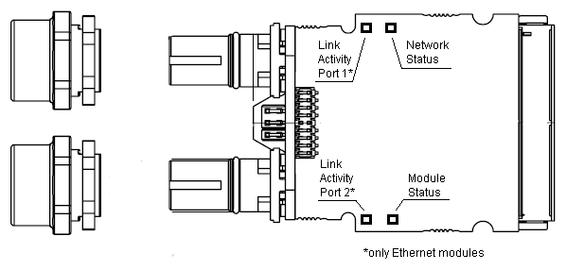           
Image X, Standard LED positions and mounting

### **Profibus**

Table X1 - Network Status / Operation Mode LED

|  |  |
| --- | --- |
| **LED State** | **Description** |
| Off | Not online / No power |
| Green | Data exchange |
| Green, flashing | Clear |
| Flashing Red (1 flash) | Parametrization error |
| Flashing Red, (2 flashes) | Profibus Configuration Error |

Table X2 – Module Status LED

|  |  |
| --- | --- |
| **LED State** | **Description** |
| Off | Not initialized. Anybus state = ‘SETUP’ or ‘NW_INIT’ |
| Green | Initialized. Anybus module has left the ‘NW_INIT’ state |
| Green, flashing | Initialized, diagnostic event(s) present. Extended diagnostic bit is set |
| Red | Exception error. Anybus state = ‘EXCEPTION’ |

Profibus does not have the Link/Activity LEDs.

### **EtherNetIP**

Table X1 - Network Status LED

|  |  |
| --- | --- |
| **LED State** | **Description** |
| Off | No power or no IP address |
| Green | Online, one or more connections established (CIP class 1 or 3) |
| Green, flashing | Online, no connections established |
| Red | Duplicate IP address, FATAL error |
| Red, flashing | One or more connections timed out (CIP Class 1 or 3) |
| *Note: A test sequence is performed on this LED during startup* | |

Table X2 – Module Status LED

|  |  |
| --- | --- |
| **LED State** | **Description** |
| Off | No power |
| Green | Controlled by a Scanner in Run state |
| Green, flashing | Not configured, or Scanner in Idle state |
| Red | Major fault (EXCEPTION-state, FATAL error, etc) |
| Red, flashing | Recoverable fault(s) |
| *Note: A test sequence is performed on this LED during startup* | |

Table X3 - Link/Activity LED

|  |  |
| --- | --- |
| **LED State** | **Description** |
| Off | No link, no activity |
| Green | Link (100 Mbit/s) established |
| Green, flickering | Activity (100 Mbit/s) |
| Yellow | Link (10 Mbit/s) established |
| Yellow, flickering | Activity (10 Mbit/s) |

### **DeviceNet**

Table X1 - Network Status LED

|  |  |
| --- | --- |
| **LED State** | **Description** |
| Off | Not online / No power |
| Green | Online, one or more connections are established |
| Green, flashing | Online, no connections established |
| Red | Critical link failure |
| Red, flashing | One or more connections timed out |
| Alternating Red/Green | Self test |

Table X2 – Module Status LED

|  |  |
| --- | --- |
| **LED State** | **Description** |
| Off | No power |
| Green | Operating in normal condition |
| Green, flashing | Missing or incomplete configuration, device needs commissioning |
| Red | Unrecoverable fault(s) |
| Red, flashing | Recoverable fault(s) |
| Alternating Red/Green | Self test |

DeviceNet does not have the Link/Activity LEDs.

## **Troubleshooting Help**

If you need further assistance, please visit our website at [www.intelligrated.com](http://www.intelligrated.com) or call

our Technical Support Department at 1-877-315-3400.